Practical No. 5
Aim : ALP for signed division of two 8-bit numbers
Name : Danish Altaf Solkar Class : CO - B
Enrolment no. : 24111590805 Batch : 2

Code :-
assume cs:code
assume ds:data
data segment
num1 DB -12H
num2 DB 05H
quo DB ?
rem DB ?
data ends
code segment
start:
MOV AX,data
MOV DS,AX
MOV AX,0000H
MOV AL,num1
MOV BL,num2
IDIV BL
MOV quo,AL
MOV rem,AH
INT 03H
code ends
end start

OUTPUT :-
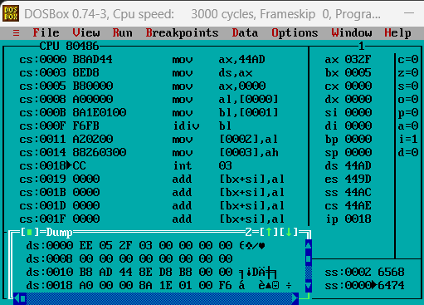

Process related  (15) | Product related  (10) | Total Marks  (25) | Signature

